|  |  |  |
| --- | --- | --- |
| **Computer Science 1** | **Lab 17B**  **Open Ended *Text File* Assignment** | |
| **Creating Graphics Backgrounds From Text Files** | | **80, 100 and 110 Point Versions** |
| **Assignment Purpose:**  Students will manipulate graphics background output by manipulating text files. | | |

For this assignment, you are actually not writing a program at all. Not only is the program, **Lab17Bst.py**, already written, you have actually already seen it. **Lab17Bst.py** is identical to the last program example from Chapter 17, **TextFiles23.py**. This was the program that created graphics backgrounds from text files. You probably noticed that 3 of the backgrounds resemble those from Nintendo’s classic *Donkey Kong* arcade game. Imagine that you are creating a new 40th Anniversary Edition of Donkey Kong that will feature a couple extra levels. Your mission is to design the backgrounds for those levels and to create the text files that will store them.

To begin, you should load the file **DK4.txt**, which is shown below:

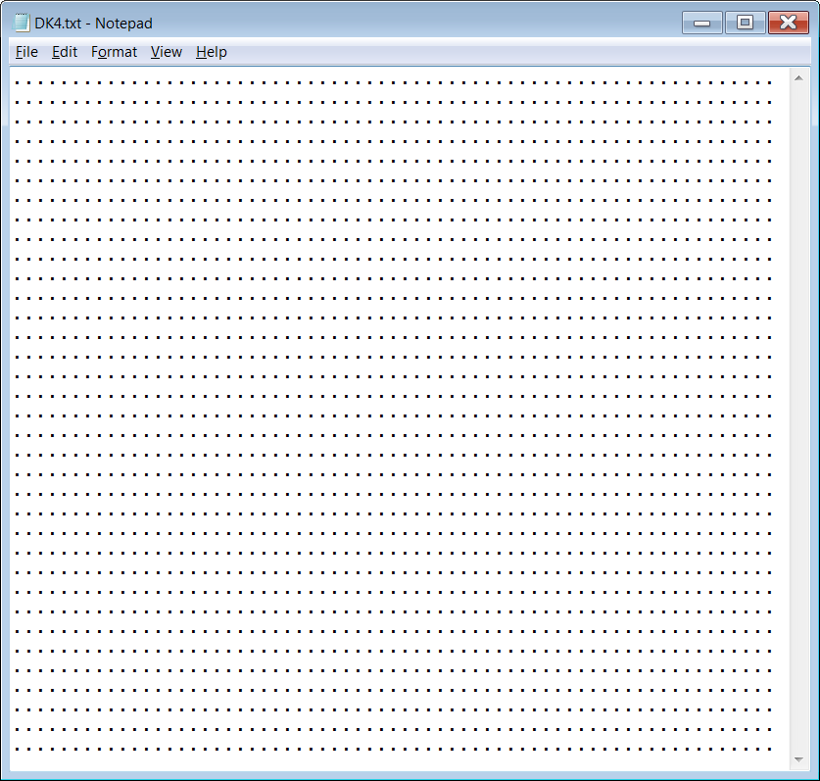

The **DK4.txt** and **DK5.txt**  files contain

35 rows of

65 periods.

Use these files to design your

new original

*Donkey Kong*

backgrounds.

Examples

of existing backgrounds

are on the next few pages.

|  |  |
| --- | --- |
|  |  |
|  | |
|  |  |
|  | |
|  |  |
|  | |

|  |  |
| --- | --- |
| Keep in mind that when designing these levels, there must be a way for *Jumpman* (Mario’s original name) to get from the bottom of the level to the top. The level can be challenging, but it must be completable and not just a bunch of random images. The level also should not just have a ladder that goes all of the way to the top. You want to make something that is interesting and would actually be fun to play. |  |

**80 Point Version**

Use the file **DK4.txt** to design the background for your original *Donkey Kong* level. This level needs to incorporate at least 4 of the 6 provided images (girders, ladders, hammers, barrels, locks and poles).

**100 Point Version**

After you finish the 80 point version, repeat the process with the file **DK5.txt**. When finished, you will have 2 original *Donkey Kong* levels. Between these 2 levels, you need to incorporate at least 5 of the 6 provided images (girders, ladders, hammers, barrels, locks and poles).

**110 Point Version**

First, do everything required for the 100-point version and have your teacher grade it.

Then you need to add a new procedure to the **Lab17Bst.py** file. This will be something like **drawGirder** or **drawLadder**, but it will display a new, original image of your own design. It cannot simply draw a solid square, nor can it simply be a copy of one of the provided images. It needs to be something original that makes sense in the game *Donkey Kong*. You then need to incorporate this new image in a logical way in at least 1 of your 2 background text files.

